|  |
| --- |
|  |

|  |  |
| --- | --- |
| **C:\Users\rkane\Desktop\NSI Marketing\Logos\NSI\nsilogo.jpg** | **Application Solution** |

**Life Safety System with Gas Leak Detection**

Neal Systems, Inc.

Systems Management Division

122 Terry Drive, Newtown, PA 18976 USA

|  |  |  |
| --- | --- | --- |
| **Introduction**  The Life Safety System (LSS) outlined in this application note was designed to detect chlorine, oxygen, and hydrogen gases for a customer in the biochemical manufacturing industry. Prior to reaching out to Neal Systems, Inc. (NSI), the customer had experienced a dangerous gas leak in their facility, prompting them to take proactive measures to ensure the safety of their employees and the surrounding community. NSI produced a customized turnkey solution, providing all the necessary hardware, engineering services, and installation for a solution that arrived on time and within budget. |  | **Contents**  **Solution Design Considerations** 2  Sensor Placement 2  Sensor Sensitivity 3  LSS Integration 3  Human Factors 3  **The NSI Solution** 3  HMI and First Responder Screens 3  Alarms and Lights 4  Installation 5  System Network 5  **Advantages of an NSI Solution** 7 |

# **Solution Design Considerations**

While there is much commonality among all LSS designs, each has its own nuances that must be addressed on an individual basis. A number of design decisions therefore have to be made in order to guarantee the system’s reliability and speed of response to a gas leak. This particular LSS design addressed the following concerns:

* Accurate gas measurement
* Required speed of response

*Neal Systems teamed closely with the customer to define the design requirements and to address the design considerations. This ensured that the application solution fully addressed the customer’s need based on the detailed factors affecting the design.*

* Type of gas that could leak
* Risk of Toxicity (Tox), Explosion (Ex), or Asphyxiation (Ox)
* Simple calibration with minimum routine maintenance
* Detailed reporting of gas leak severity and location
* Facility layout
* Continuous system health self-monitoring
* Placement and quantity of sensors
* Risk assessment for personnel safety, plant equipment damage, and product loss
* Complements customer standard operating procedures (SOPs)
* Use of lights, horns, alarm displays, historical trends, and first responder panels

The application solution to address these concerns had to consider a wide range of factors to include:

## Sensor Placement

Placement of sensors had to address:

* *Molecular weight of gases to be detected* –
  + Chlorine – Because chlorine gas is heavier than air, the sensors had to be near the floor to detect chlorine build-up as it happens.
  + Oxygen – The sensors were placed at breathing-height in order to detect Oxygen depletion.
  + Hydrogen – Being light than air, hydrogen sensors were placed near the ceiling.
* *Air currents within the building* – Sensors must be placed where gases in a room will most likely pass near the sensors.
* *Humidity, temperature, and the pressure* – These are all contributing factors that affect the area around the source of a gas leak.
* *Degree of coverage* – How many sensors does the LSS require to cover the probable sources of a leak and other areas to ensure comprehensive coverage and protection?

## Sensor Sensitivity

Dangerous concentration levels vary greatly between different types of gases. Moreover, they pose different types and degrees of risk (asphyxiation, toxicity, explosion, or a combination thereof). It is therefore critical to ensure sensors have the necessary sensitivity in order to avoid personnel injury, increased cost due to gas loss, and damage to plant assets.

Because of the possible risks, the sensors also needed to be able to detect the target gases before they reached dangerous levels and to avoid false readings due to cross sensitivity. To reduce the possibility of inaccurate readings from a mixture of gases, filters were included in the LSS design.

## LSS Integration

This project needed sensors placed throughout the plant with a few located outside.  Because equipment had to be placed some distance away from the LSS central processor, the integration of all the sensors, alarms, and interfaces posed a challenge.   A way to establish an effective communication network throughout the facility was therefore essential.

## Human Factors

The customer’s Standard Operating Procedures (SOP) posed strict requirements that hardware and software must meet before being implemented on-site. Aspects of the SOP to consider included:

* Procedures to alert people in the vicinity of a gas leak.
* Method used to notify personnel who are not in the immediate area in order for them to take action and shut down equipment.
* The visual displays and data logging systems needed if First Responders are to pinpoint the source and type of the gas leak.
* Records or trending requirements to report past readings and events.

# **The NSI Solution**

*Every NSI design decision was carefully weighed in close coordination with the customer. This ensured that the NSI solution provided the highest possible levels of employee safety and equipment protection at optimal cost.*

Detailed below is the solution to the many engineering challenges faced during the implementation of this gas detection LSS.

## HMI and First Responder Screens

The design of screens for the HMI is important as it is often the best way to identify the source and severity of a leak. NSI worked with the customer at every phase of the HMI design process to create a simple, easy-to-use solution consistent with the customer needs.

For the best performing system, it is imperative that the HMI be intuitive for the user. With 30 gas detection stations positioned throughout the plant, it was decided that a graphic display of the facility overlaid with the status of the alarms was the fastest way for operators to identify the location of a leak. Without this type of functionality, operators and responders in many facilities would otherwise have to find the source of the alarm by walking from sensor to sensor – a potentially dangerous situation.

Figure 1 shows the below screen display from the actual application solution, which used a Red Lion Graphite HMI.

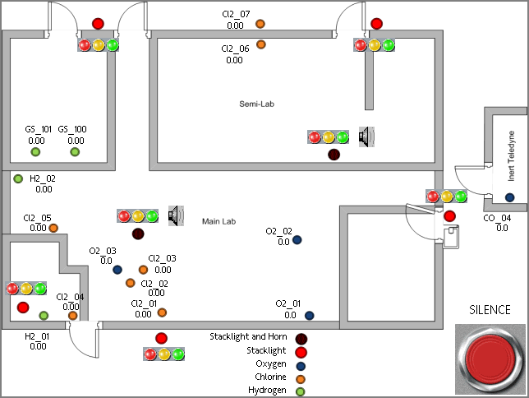

Figure 1. Red Lion Graphite HMI for LSS.

(Note: Identifying information removed.)

## Alarms and Lights

Safety precautions must be taken when relying on alarms and lights to indicate potentially dangerous environments. In addition to yellow and red lights indicating warnings and alarms respectively, a green light adds another level of safety. Rather than relying on just an unlit red or yellow light, which could simply be caused by a power failure to the light stack or to bulb failures, the green light provides a positive indication of safety.

*It is critical to collaborate with the system users in the design of any LSS. Optimal positioning of alarm lights, horns, and test pushbuttons cannot be achieved without a comprehensive understanding of how the building is used on a day to day basis.*

An alternative method to a green light is to install a test pushbutton outside the potentially dangerous area. When pressed, the pushbutton will light all alarm lights in that area. This enables personnel to confirm that all alarm lights are in working order thus confirming that a lack of alarm lights really is a positive indication of a safe environment.

Sensor Solution

As previously noted, the molecular weight of the target gases was crucial to determining the height at which the sensors must be installed.

The Dräger Polytron 7000 was chosen as the most cost-effective sensor that offered an acceptable level of reliability and longevity while providing the accuracy required to measure the target gases at their lowest safe exposure limits. Dräger's electrochemical sensors have patented technology to compensate for environmental factors such as temperature, humidity, and pressure, resulting in less maintenance and longer lasting calibration. Dräger’s sensors also have a lower drift level over time, with +/-1% drift over an 18-month period, in contrast to the +/-2 to 4% drift of competing products. In addition, Dräger sensors boast among the longest lifetimes in the industry, thereby offering superior safety with a significantly lowered cost of ownership. More information about the sensor can be found at [Draeger Polytron 7000](http://www.draeger.com/sites/en_aunz/Pages/Chemical-Industry/Draeger-Polytron-7000.aspx).

## Installation

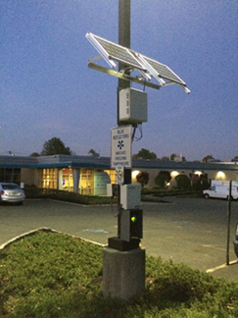

Customized Solar

Panel Solution

As a full service company, NSI can also install the systems it designs. All the enclosures for sensor stations are built in-house to exacting standards to ensure the hardware lasts. For this project, over 10 enclosures were built. Since the customer’s facility sits in a natural recess in the ground where heavier-than-air chlorine can pool, the customer and NSI determined that two additional sensors should be placed outside the main building. A customized solar-powered solution was developed and installed to avoid the need for trenching across the parking lot to accommodate a power line.

## System Network

NSI networked the hardware in the detection systems for this project. In this application solution, all the data from the remote sensors is sent to a Schneider Eurotherm PLC that triggers alarms and lights if the levels of chlorine in the air exceed safe exposure limits for personnel. Sensors were wired directly to the PLC whenever possible. Where sensors were too remote for a hardwired solution, ELPRO wireless Ethernet radios were installed for wireless connectivity. The ELPRO radios significantly simplified the project through their self-healing, auto-routing network that provides added redundancy to the wireless network. Figure 2 (next page) depicts the full system topology for the application solution, showing the structure of the network and integration of the components.



Figure 2. LSS Gas Safety Topology

NSI offers a full range of industrial networking product solutions including cell modems, Ethernet switches, and radios from industry-leading manufacturers such as Red Lion, Hirschman, and ELPRO. The wide range of NSI’s product offerings allows great flexibility in the design of a network solution.

# **Advantages of an NSI Solution**

In contrast to a multi-company project, NSI handles the entire process of the project from inception to installation. This means the customer only has to deal with one company – all questions, requests, and support are directed to a single, dedicated project manager. NSI is therefore able to bundle services to the customer and centralize project engineering and management. The result – an application solution in a single, complete package with a typical associated reduction in costs.

The Dräger gas detection sensors are among the most reliable in the industry, reducing the need for maintenance for system implemented by NSI. Typical calibration times are every 6 months, and the sensors include patented health diagnostics that allow for greater safety factors and a lower cost of ownership.

Options available with an NSI LSS include:

* Remote alarming via Short Message Services (SMS) or email
* Remote VPN access for the customer to the touch screen devices
* Remote diagnostics and NSI support through an encrypted cell modem connection
* Additional cyber security protection using industrial firewalls
* Multi-site viewing capabilities for centralized security offices

Neal Systems can provide you

the most **effective** and **efficient** **solution** available

**to meet your need**.

Contact us at:

Email: [sales@nealsystems.com](mailto:sales@nealsystems.com)

or

Telephone: 215-968-7577.

*Visit our website at* [*www.nealsystems.com*](http://www.nealsystems.com)

|  |
| --- |
|  |